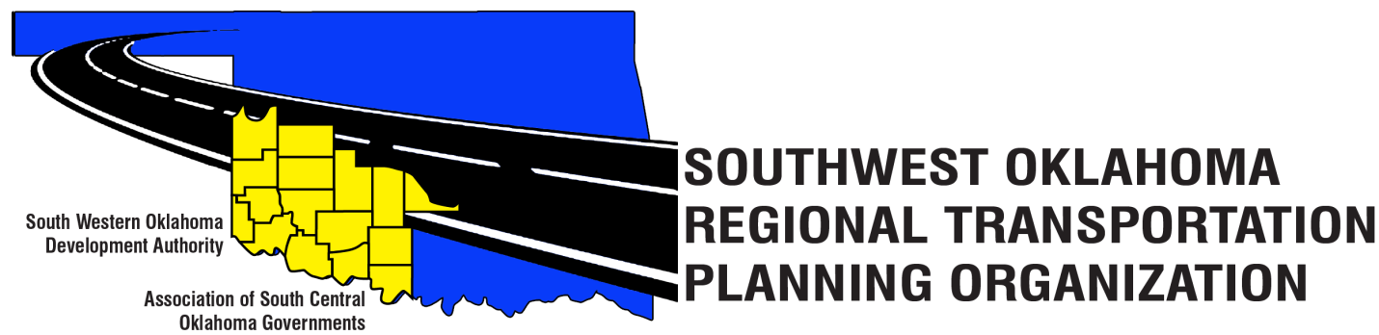

SORTPO Policy Board

Meeting Agenda

January 24, 2019, 10:00 a.m.
Videoconferencing
Western Technology Center  Adult Education Bldg, Assembly Rm 2  621 Sooner Dr.  Burns Flat, OK 73624  580-562-3181 | Red River Technology Center  JDM Business Center, Rm B113  3300 W. Bois D’Arc  Duncan, OK 73533  580-255-2903

Policy Board Members | Location | Policy Board Members | Location | Policy Board Members | Location
Brent Almquist | Burns Flat | Jay Earp | Duncan | Heather Sheppard | Burns Flat
Anita Archer | Burns Flat | Marilyn Feaver | Duncan | Mark Skiles | Burns Flat
Tim Binghom | Burns Flat | Shawn Freie | Duncan | Sandy Settle | Burns Flat
Kevin Bloss | Duncan | Debora Glasgow | Burns Flat | Clark Southard | Duncan
Dale Bunn | Duncan | Lyle Miller | Burns Flat | Bill Spurlock | Burns Flat
Kirk Butler | Burns Flat | Cendie Newman | Burns Flat | Tom Zigler | Duncan
Jerry Dean | Burns Flat | Lyle Roggow | Duncan
- Call to Order
- Roll Call
- Introduction of Guests
- Approval of the minutes for the October 25, 2018 meeting.
- Hold a Public Hearing to receive and discuss comments for:
A. 2040 Grady County Long Range Transportation Plan.
B. 2040 McClain County Long Range Transportation Plan.

- Discuss and consider adopting by Resolution:
  - Resolution #2019-1 approving the 2040 Grady County Long Range Transportation Plan.
  - Resolution #2019-2 approving the 2040 McClain County Long Range Transportation Plan.

- Discuss and provide comments for the Amendment 1 to the thresholds for the following plans:
A. 2040 Jefferson Long Range Transportation Plan
B. 2040 Stephens Long Range Transportation Plan
C. 2040 Tillman Long Range Transportation Plan

8. Discuss and consider establishing a 30 day public review and comment period
On the Amendment 1 to the thresholds for the following plans:
A. 2040 Jefferson Long Range Transportation Plan
B. 2040 Stephens Long Range Transportation Plan
C. 2040 Tillman Long Range Transportation Plan

9. Discuss and consider approving the 2040 Population and employment projections for:
A. Caddo County
B. Comanche County

10. Old Business
11. New Business
12. Reports and comments
13. Adjourn

