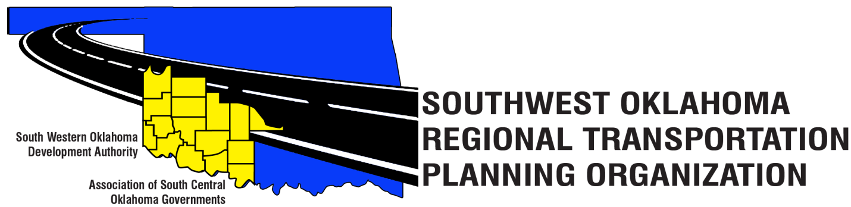
August 26, 2019
PRESS RELEASE
“For Immediate Release”
30 Day Public Review and Comment Period

The Southwest Oklahoma Regional Transportation Planning Organization (SORTPO) is seeking public comment on the
- Amendment #1 2036 Beckham County Long Range Transportation Plan,
- Amendment #2 2035 Custer County Long Range Transportation Plan
- Amendment #1 2040 Jackson County Long Range Transportation Plan, and

The Long Range Transportation Plan establishes the goals and transportation strategies for addressing the County’s transportation needs. The amendment of these plans proposes to modify the population and employment by traffic analysis zones. Prior to adoption of the plan or amending a plan there is a 30-day public comment period which will end on September 24, 2019. During this comment period individuals, agencies, and organizations are encouraged to review the document and submit comments. The Plan is available from the SORTPO offices located at
ASCOG
Tom Zigler
802 W. Main St.
Duncan, Oklahoma

SWODA
Julie Saners, SORTPO,
420 Sooner Dr., PO Box 569,
Burns Flat, OK 73624
or to Julie@swoda.org

