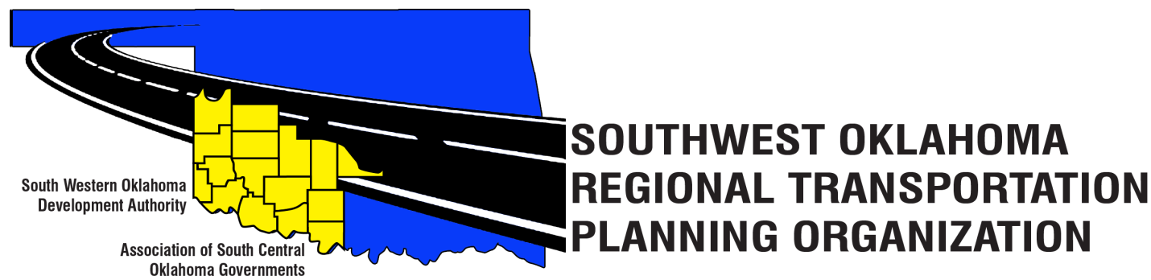

SORTPO Policy Board

Meeting Agenda

November 21, 2019, 10:00 a.m.
Videoconferencing
Western Technology Center  Adult Education Bldg.,  Assembly Room 2  Burns Flat, OK 73624  580-562-3181 | Red River Technology Center  JDM Business Center, Rm B112  3300 W. Bois D’Arc  Duncan, OK 73533  580-255-2903

Policy Board Members | Location | Policy Board Members | Location | Policy Board Members | Location
Brent Almquist | Burns Flat | Shawn Freie | Duncan | Sandy Settle | Burns Flat
Anita Archer | Burns Flat | Debora Glasgow | Burns Flat | Mark Skiles | Burns Flat
Tim Binghom | Burns Flat | Heather Harding | Burns Flat | Clark Southard | Duncan
Dale Bunn | Duncan | Lyle Miller | Burns Flat | Bill Spurlock | Burns Flat
Kirk Butler | Burns Flat | Cendie Newman | Burns Flat | Dale Winkler | Duncan
Jerry Dean | Burns Flat | Lyle Roggow | Duncan | Tom Zigler | Duncan
Jay Earp | Duncan
- Call to Order
- Roll Call
- Introduction of Guests
- Approval of the minutes for the September 24, 2019.
- Meeting Schedule
- New SORTPO Technical Committee members
- Census 2020
- Transit
- Chapter 1
- Old Business.
- New Business.
- Reports and Comments.
- Adjourn.

