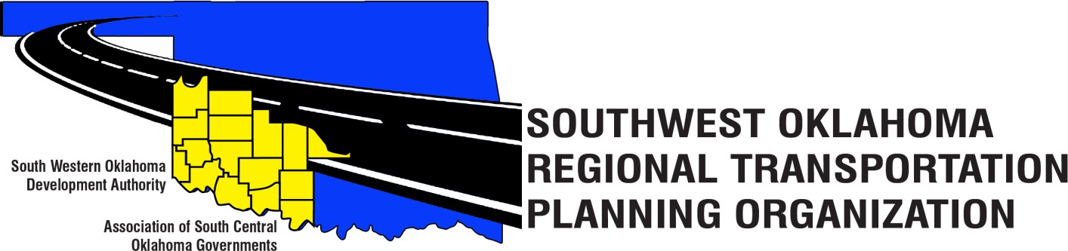

SORTPO Technical Committee Meeting Agenda
November 14, 2019 10:00 a.m.
Videoconferencing
Western Technology Center Adult Education Bldg,  621 Sooner Dr.  Burns Flat, OK 73624 580-562-3181 | Red River Technology Center JDM Business Center, Rm B112 3300 W. Bois D’Arc  Duncan, OK 73533  580-255-2903

Technical Committee Members | Location | Technical Committee Members | Location
Bryce Bohot | Duncan | Danny Britton | Burns Flat
Elesia Church | Burns Flat | Lee Litterell | Burns Flat
Jim Mason | Burns Flat | Kevin Ouellette | Duncan
Julie Sanders | Burns Flat | Ashley Slaughterback | Burns Flat
Basil Weatherly | Burns Flat | Tom Zigler | Duncan

- Call to Order.
- Roll Call.
- Introduction of Guests.
- Approval of the minutes for the September 19, 2019 meeting.
- Discuss and recommend to the SORTPO Policy Board approval of Amendment #1 to the FFY 2020 Planning Work Program (PWP).
- Discuss and provide comments on draft Chapters 1 and 2 of the regional transportation plan.
- Discuss and provide comments on SORTPO mission and vision.
- Discuss and provide comments on the FY 2020 calendar of meetings.
- Old Business
- New Business
- Reports and Comments
  - Rural Opportunities to Use Transportation for Economic Success (ROUTES) Initiative
  - 2020 Census – November 14th & 21st – Regional Training
  - Statewide Mobility and Public Transit Plan
  - ASCOG
- Adjourn
Notice of this meeting was made to Washita County Clerk by annual posting and this agenda was visibly displayed on the front door of the SWODA office at 420 Sooner Dr., Burns Flat, OK and ASCOG office at 802 W. Main Street, Duncan, OK on November 8 at 8:00 a.m. If individual with disabilities who require accessible alternative formats of the agenda and related meeting materials and/or auxiliary aids/services to participate in the meeting, notification to SWODA Director of Transportation at (580)-562-4885 at least 48 hours prior to the scheduled meeting is encouraged to make necessary accommodations. Southwest Oklahoma Regional Transportation Planning Organization (SORTPO) may waive the 48-hour rule if interpreters for the deaf (signing) or translation services for LEP individual are not necessary accommodation.

