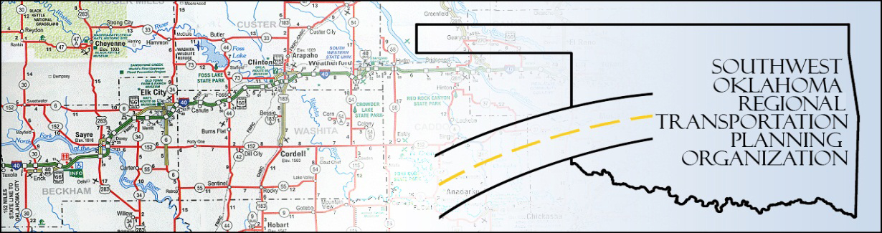

SORTPO

Policy Board Minutes
SWODA Conference Room
Building 420 Sooner Drive
Burns Flat, OK 73624
Thursday, March 26, 2015
10:30 a.m.

Policy Board Members | P/A | Policy Board Members | P/A
Brent Almquist | P | Mike Galloway | P
Anita Archer | P | Debora Glasgow | P
Cary Carrell | P | Lyle Miller | P
Jeff Casida | A | Heather Sheppard | P
Jerry Dean | P | Mark Skiles | P
Greg Derieg | A | Clark Southard | P
Marilyn Feaver | P | Bill Spurlock | A

- Call to Order:

Vice-Chairman Lyle Miller welcomed members, guests and called the meeting to order.

- Roll Call:

Roll was called and it was declared a quorum was present. Also in attendance: Staff members: Alex Damon, Jana Harris and Danette Traugott and RPO Consultant: Julie Sanders.

- Policy Board Update:

Debora Glasgow provided the Policy Board Update, including information regarding the reformatting of the board makeup.
- Voting Items:

- The new schedule of meetings was presented. Motion to accept was made by Jerry Dean and seconded by Clark Southard; all in favor.

- Board Officers: Chairman: Lyle Miller was nominated by Anita Archer and seconded by Jerry Dean, all in favor. Vice-chairman: Mike Galloway was nominated by Clark Southard and seconded by Marilyn Feaver, all in favor. Secretary: Anita Archer was nominated by Cary Carrell and seconded by Jerry Dean, all in favor.

- Approval of Technical Committee members: Motion to accept was made by Clark Southard and seconded by Jerry Dean, all in favor. (Mark Skiles joined the meeting at 10:45 a.m.)

- Discussion Items:

Long Range Transportation Plan (LRTP) was discussed. Also specific attention was given to goal policies. Route 66 connectivity, signage and maintenance issues were also discussed. Additional verbiage and suggestions for the draft of the LRTP were also discussed.

6. New Business:

There were none at this time.

7. Remarks by Members:

There were none at this time.

8. Remarks by Guest:

There were none at this time.

9. Adjourn:

Being no further business, motion to adjourn was made by Mike Galloway and seconded by Clark Southard. The meeting was adjourned at 11:55 a.m.

ATTEST:

___________________________ _________________________
(Chairman) (Secretary)

