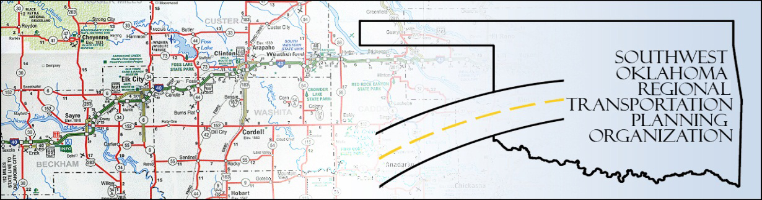

SORTPO

Policy Board Minutes
SWODA Conference Room
Building 420 Sooner Drive
Burns Flat, OK 73624
Thursday, April 23, 2015
10:30 a.m.

Policy Board Members | P/A | Policy Board Members | P/A
Brent Almquist | P | Mike Galloway | A
Anita Archer | P | Debora Glasgow | P
Cary Carrell | P | Lyle Miller | P
Jeff Casida | P | Heather Sheppard | P
Jerry Dean | A | Mark Skiles | A
Greg Derieg | A | Clark Southard | P
Marilyn Feaver | P | Bill Spurlock | P

- Call to Order:

Chairman Lyle Miller welcomed members, guests and called the meeting to order.

- Roll Call:

Roll was called and it was declared a quorum was present. Also in attendance were SWODA Staff members Jana Harris, Danette Traugott, ODOT Representative Laura Chaney and RPO Consultant Julie Sanders.

3. Approval of Minutes.:

The minutes of the March 26th meeting were discussed. Motion was made by Clark Southard and seconded by Anita Archer, all in favor.

4. Voting Items Recommended by the Technical Committee:

- Endorsement of the SWODA/SORTPO Civil Rights Policies was presented. There was discussion about the policies and why they were needed. Motion to accept was made by Clark Southard and seconded by Bill Spurlock; all in favor.

- Acceptance of the draft of the 2035 Long Range Transportation Plan (LRTP). Julie Sanders made the recommendation to the board that the LRTP was not ready to be accepted as presented and asked for a special meeting on May 21st at 10:30 for board approval. After that day the 30 day public review could start on May 22nd and the plan could be adopted on June 25th. The plan would need to be mailed to the policy board no later than May 19th. No action was taken on this item.

- No action taken.

5. Discussion Items:
It was decided to cancel the May 28th meeting and reschedule it for May 21st. Motion was made by Clark Southard and seconded by Heather Sheppard, all in favor.

6. New Business:

Debora Glasgow informed the board that SWODA Board of Trustee approved the revised SORTPO By-Laws and Policy Board membership at their monthly meeting. Jana Harris reported that Joe Ridley from the Technical Committee recommended that Tim Tutten, Risk Manager with Oklahoma Department of Transportation Division V be placed on the Technical Committee. She stated that the Policy Board had to approve his placement. Motion was made by Clark Southard and seconded by Anita Archer, all in favor.

7. Remarks by Members:

There was discussing from Marilyn Feaver that since the regional plan was being done county by county if the technical committee would change and have new members from those counties. Julie Sanders suggested bringing in Advisory Committees from the county the plan is being done for at that time. Debora Glasgow stated the county commissioners on the SWODA Board of Trustees wanted to be included on the technical committee when planning is done for their county.

8. Remarks by Guest:

There were none at this time.

9. Adjourn:

Being no further business, motion to adjourn was made by Clark Southard and seconded by Jeff Casida. The meeting.

ATTEST:

___________________________ _________________________
(Chairman) (Secretary)

