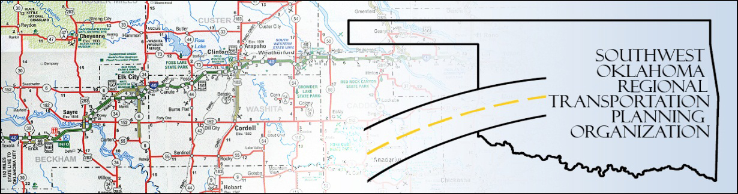

SORTPO

Policy Board Minutes
SWODA Conference Room
Building 420 Sooner Drive
Burns Flat, OK 73624
Thursday, May 21, 2015
10:30 a.m.

Policy Board Members | P/A | Policy Board Members | P/A
Brent Almquist | P | Mike Galloway | A
Anita Archer | P | Debora Glasgow | P
Cary Carrell | P | Lyle Miller | P
Jeff Casida | P | Heather Sheppard | P
Jerry Dean | A | Mark Skiles | P
Greg Derieg | A | Clark Southard | P
Marilyn Feaver | A | Bill Spurlock | P

- Call to Order:

Chairman Lyle Miller welcomed members, guests and called the meeting to order.

- Roll Call:

Roll was called and it was declared a quorum was present. Also in attendance were SWODA Staff members Alex Damon and Jana Harris, ODOT Representative Laura Chaney and RPO Consultant Julie Sanders.

3. Approval of Minutes.:

The minutes of the April 23, 2015 meeting was discussed and approved noting title change for Mr. Miller from Vice-Chairman to Chairman. Motion was made to approve the minutes with the change by Clark Southard and seconded by Anita Archer, all in favor.

4. Voting Items Recommended by the Technical Committee:

a. Acceptance of the final draft of the 2035 Long Range Transportation Plan (LRTP). Alex Damon and Julie Sanders held discussion on the final draft and the next steps that need to be taken before final approval. After much discussion by committee members and guests questions were answered a motion was made by Clark Southard and seconded by Heather Sheppard, all in favor.

b. Set the 30-day Public Review and Comment Period for the LRPT from May 22, 2015 through June 23, 2015. After discussion a motion was made by Mark Skiles and seconded by Clark Southard, all in favor.

5. New Business:

Alex Damon discussed information he had received from the Tribal Transit Authority and how it would be added to the LRTP.

6. Remarks by Members:

None at this time.

7. Remarks by Guest:

There were none at this time.

8. Adjourn:

Being no further business, motion to adjourn was made by Clark Southard and seconded by Jeff Casida. The meeting.

ATTEST:

___________________________ _________________________
(Chairman) (Secretary)

