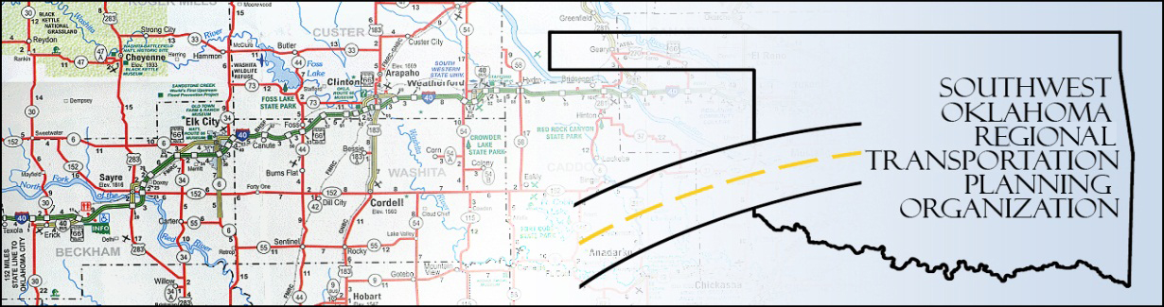

SORTPO

Public Hearing
SWODA Conference Room
Building 420 Sooner Drive
Burns Flat, OK 73624
Thursday, June 25, 2015
10:30 a.m.

Policy Board Members | P/A | Policy Board Members | P/A
Brent Almquist | P | Mike Galloway | A
Anita Archer | A | Debora Glasgow | A
Cary Carrell | A | Lyle Miller | A
Jeff Casida | P | Heather Sheppard | A
Jerry Dean | A | Mark Skiles | A
Greg Derieg | A | Clark Southard | P
Marilyn Feaver | P | Bill Spurlock | A

The SORTPO Public Hearing was called to order at 10:15 a.m. The policy board members that were present are listed above. Also in attendance were SWODA staff members Alex Damon and Jana Harris, ODOT Representative Laura Chaney and RPO Consultant Julie Sanders.

There was no additional public in attendance for remarks.

The SORTPO Public Hearing closed at 10:30 a.m.

