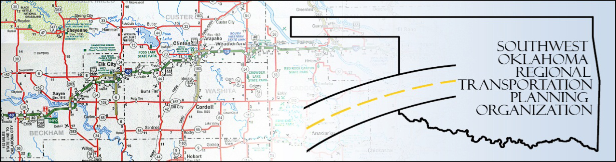

SORTPO

Policy Board Minutes
SWODA Conference Room
Building 420 Sooner Drive
Burns Flat, OK 73624
Thursday, September 24, 2015
10:30 a.m.

Policy Board Members | P/A | Policy Board Members | P/A
Brent Almquist | P | Debora Glasgow | P
Anita Archer | A | Lyle Miller | P
Cary Carrell | A | Heather Sheppard | P
Jeff Casida | A | Mark Skiles | A
Jerry Dean | A | Clark Southard | P
Marilyn Feaver | P | Bill Spurlock | P
Mike Galloway | P

- Call to Order:

Chairman Lyle Miller welcomed members, guests and called the meeting to order.

- Roll Call:

Roll was called and it was declared a quorum was present. Also in attendance were SWODA staff members Alex Damon and Jana Harris, ODOT Representative Laura Chaney and Office of Emergency Management Tracy Bender.

3. Approval of Minutes.:

The minutes of the June 25, 2015 meeting was discussed. Motion was made to approve the minutes by Clark Southard and seconded by Bill Spurlock, all in favor.

4. Discussion Items:

a. Discussion of Long Range Transportation Plan (LRTP) process in Beckham and Roger Mills Counties:

Alex Damon gave an update on what has been going on since the last Policy Board meeting with the LRTP process in Beckham and Roger Mills Counties. Mr. Damon answered questions in regard to the Regional LRTP and what happens once all the counties are done. He also held discussion on the concerns from Clark Southard and Marilyn Feaver about the backwards approach to planning.

i. New Members:

Mr. Damon informed the board that Ms. Cendie Newman, Executive Director of Red River Transportation, will be a new member of the Policy Board.

ii. Surveys/Target Groups:

There was discussion of what target groups needed to be approached to leave surveys that need to be completed so the data can be used for Beckham and Roger Mills Counties LRTP.

5. a. Review/discuss and/or vote to approve Transportation Alternatives Program (TAP) from ODOT; specifically Application Criteria and Scoring as recommended by the Technical Committee.

Mr. Damon held discussion on the Transportation Alternatives Program (TAP) application criteria. The Technical Committee recommended to the Policy Board to use a floating scale on rating the applications. He explained that funding is in place through Federal Highways through ODOT but there is not a release date as of yet.

Clark Southard recommended adding 3e. (Does the project affect economic development in the applicant’s area?) to the application criteria. Motion was made to add 3e by Clark Southard and seconded by Heather Sheppard, all in favor. Mr. Southard also moves to strike the word educational from 3d. and Heather Sheppard seconded that motion, all in favor.

Motion was made to approve the Transportation Alternatives Program (TAP) Application Criteria as amended by Clark Southard and seconded by Marilyn Feaver, all in favor.

b. Consider, Discuss and/or Vote to Approve Updated Planning Work Program (PWP).

Mr. Damon discussed changes that needed to made to the PWP budget numbers and other typos that needed to be corrected. Motion was made by Clark Southard to accept the changes to the PWP as noted and Bill Spurlock seconded that motion, all in favor.

Laura Chaney explained that the estimated hours in the PWP needed to be complete before submitting to FHWA.

6. New Business:

None at this time.

7. Remarks by Members:

Michael Galloway introduced his guest Tracy Bender from Oklahoma Emergency Management.

8. Remarks by Guest:

None at this time.

9. Adjourn:

Being no further business, motion to adjourn was made by Clark Southard.

ATTEST:

___________________________ _________________________
(Chairman) (Secretary)

