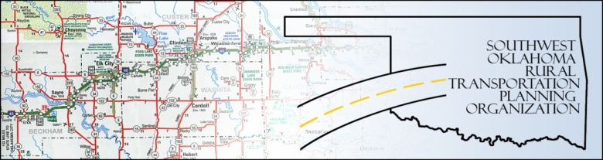

SORTPO TECHNICAL COMMITTEE MEETING Jan. 15, 2014
Meeting Minutes
Attendance: Basil Weatherly Monty Proffitt
Mike Weixel Jim Mason
Elisia Church Alex Damon (staff)
Joe Ridley Lee Littrell
The technical committee meeting was called to order by Alex Damon at 10:35am.
After roll call and introductions, the minutes of the December 18th meeting were approved. Motion by Weatherly, Second by Ridley, all in favor.
Discussion to make recommendations to the Policy Board in the following topics:
- Pop. and Employment BaseLine and 3035 projections: Discussion of Tech Committee to recommend to Policy board to use 2010 census data, and recommends growth thru 2025 only (last 10 yrs are “flat”) – changed from previous recomm. of 15 years flat.
- Key Trends and Issues: Challenges discussed; aging population, Ridley restates (by request) point about “common sense” approach to “developers” and economic development. Bring Policy Board the perspective of ALL parties involved.
- Goal Categories: (broad goals) discussion of inclusion within categories as presented at last meeting; consensus is OK with 6 Goals as listed on goal sheet.
- Survey (Custer County): discussion of on-line and elderly access. Ridley recommends using social media (on-site completion) for surveys.
- Schedule for development of LRTP: discussion of schedule; all members ok with joint meeting(s) (policy/technical), and for the Policy Board to change meeting time to 4th Tuesday of the month, quarterly.
Feb 24th selected for Policy/Tech committee to meet together. (additional Tech Comm only if needed prior to joint meeting).
New Business: Discussion of Tribal invitation and inclusion, with Damon Dunbar (Cheyenne/Arapaho Tribes) to assist.

Meeting was adjourned at 11:40 am.

