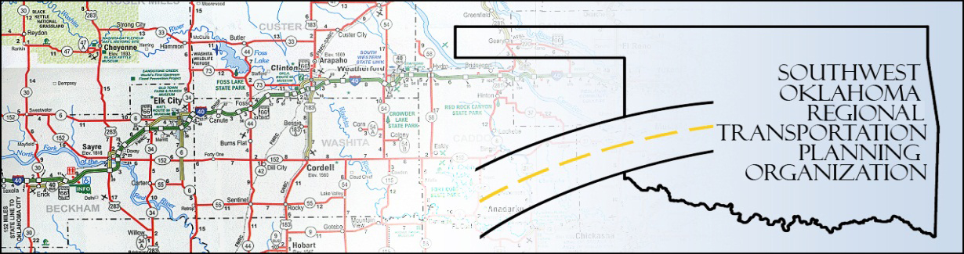

SORTPO

Technical Committee Minutes
SWODA Conference Room Building 420 Sooner Drive Burns Flat, OK 73624
May 19, 2016
8:00 a.m.
Technical Committee Members | P/A | Technical Committee Members | P/A
Laura Chaney | P | Jeff Morton | P
Elesia Church | P | Monty Profitt | P
Becky Cockrell | P | Joe Ridley | A
Jana Harris | P | Tim Tutten | A
Lee Litterell | P | Basil Weatherly | P
Jim Mason | P | Mike Weixel | A

Guests – Tom Zigler ASCOG, Richard Rogalski City of Lawton
1. Call to Order:
The technical committee meeting was called to order by Jana Harris.

2. Roll Call – Introductions

3. Approval of Minutes:

The minutes of the April 21, 2016 meeting were discussed. Motion was made by Basil Weatherly to approve minutes and seconded by Lee Litterall, motion passed.
4. Discuss and scored TAP application for Transportation Alternatives Grant Program (TAP). Jana Harris and Becky Cockrell presented information on the TAP program and process for evaluating and scoring the 20 applications presented today. A slideshow depicting a summary of the applications was shown and utilized as a guide for the Technical Committee and guests. The Tech Committee and guests scored and approved 20 applications for TAP Grant 2016 application cycle. It included 10 for ASCOG, 5 for SODA, 5 for SORTPO/SWODA. After a lengthy discussion on the applications motion was made by Lee Litterall to approve and recommend to the SORTPO Policy Board, seconded by Basil Weatherly the scoring of the 20 applications, motion passed. (NOTE: Agenda items 4 and 6a were discussed simultaneously and one vote was presentenced for these two items).

5. Discuss LRTP chapters 1, 2 and 3 for Beckham County and Roger Mills The Policy Board had some question regarding the population projection. The draft Chapters 1, 2, and 3 for Beckham County and Roger Mills County LRTPS were distributed. Due to the time Staff asked that the Committee review the draft chapters at home and Staff would send an email identifying specific focus areas such as 2035 population and employment. Traffic Analysis Zone maps for the counties and cities were also distributed. Comments on the draft will need to be returned within 2 weeks.

6. Discuss and consider recommending to SORTPO Policy Board the following:

- Tap applications (See Item 4)

- 2035 Population and employment projections for Beckham County LRTP and Roger Mills LRTP. – No action taken.

7. New Business:

8. Reports and Comments:

9. Basil Weatherly moved adjournment, Jeff Morton seconded.

