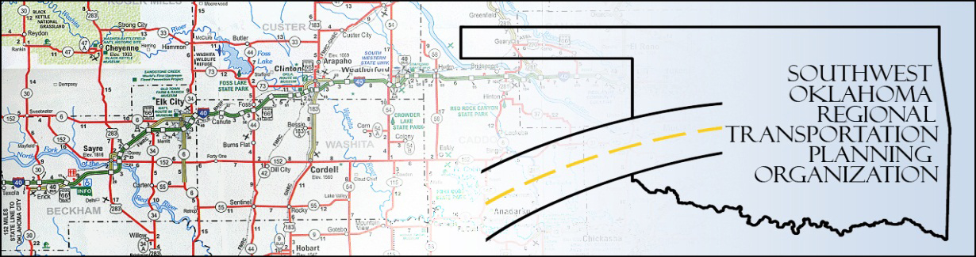

SORTPO

Policy Board Minutes
SWODA Conference Room
Building 420 Sooner Drive Burns Flat, OK 73624
Thursday, May 26, 2016
10:30 a.m.

POLICY BOARD MEMBERS | P/A | POLICY BOARD MEMBERS | P/A
Brent Almquist | A | Debora Glasgow | P
Anita Archer | P | Lyle Miller | P
Cary Carrell | A | Cendie Newman | A
Jeff Casida | P | Heather Sheppard | P
Jerry Dean | P | Mark Skiles | P
Marilyn Feaver | P | Clark Southard | P
Mike Galloway | P | Bill Spurlock | P

- Call to Order:
Meeting called to order at 10:30 a.m. by Chairman Lyle Miller.

- Roll Call and declaration of quorum:
by Becky Cockrell.

3. Approval of Minutes:
The minutes of the April 28, 2016 were approved with no change. Motion was made by Clark Southard to approve the minutes with change and seconded by Marilyn Feaver, motion passed.

- Discuss and consider approving the SORTPO Technical Committee’s applications for the Transportation Alternative Program (TAP) Grant applications:
Applications were reviewed and discussed. Motion made by Clark Southard to approve the applications and seconded by Jeff Casida, motion passed.

- Discuss and consider approving 2035 Population and employment projections for Beckham County LRTP and Roger Mills County LRTP.
5A. Motion made by Anita Archer that Beckham County be at 2% growth for both employment and population growth and seconded by Heather Sheppard, motion passed.
*Clark Southard recommended that agenda item #5 be split as A and B to distinguish between Beckham and Roger Mills County. Chairman Miller asked all in favor: all say aye.
5B. Motion made by Anita Archer that Roger Mills County be at 2% growth for employment and 1% population growth and seconded by Heather Sheppard, motion passed.

- New Business:
Julie Sanders discussed the distribution of the draft Chapters 1, 2 and 3 of the Beckham County and Roger Mills County 2035 LRPT. There is not time to review this information and some of the data in Chapter 32 of the respective plans is void of information related to future growth. An Email will be sent outlining specific areas of the draft chapters to consider. The same information was provided to the Technical Committee to comment on they have a deadline of June 6th to report to Becky.
Debora Glasgow asked if the population and employment in Chapter 1, 2, and 3, will be tweaked based upon the motion.
Julie Sanders replied that the data in Chapters 1, 2, and 3 will be modified based upon the Policy Board’s recommendations of future growth.

- Reports and Comments:
Debora Glasgow informed board members that Cary Carrell has retired and Kirk Butler will be his replacement on this board.
Being no further business, motion made by Mark Skiles and to adjourn meeting and second by Anita Archer, motion passed. Meeting was adjourned at 11:35 a.m.

ATTEST:

___________________________ _________________________
(Chairman) (Secretary)

