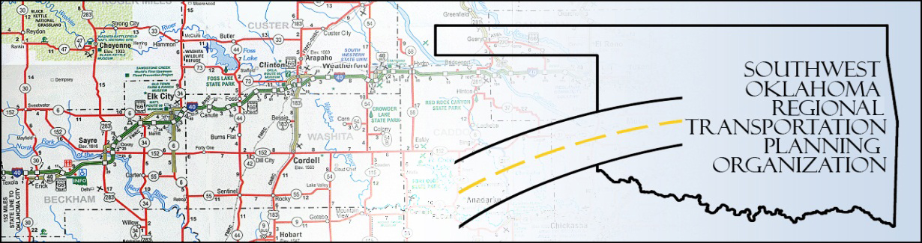

SORTPO

Policy Board Minutes
SWODA Conference Room
Building 420 Sooner Drive Burns Flat, OK 73624
Thursday, January 28, 2016
10:30 a.m.

Policy Board Members | P/A | Policy Board Members | P/A
Brent Almquist | A | Debora Glasgow | P
Anita Archer | P | Lyle Miller | P
Cary Carrell | P | Heather Sheppard | A
Jeff Casida | P | Mark Skiles | P
Jerry Dean | A | Clark Southard | A
Marilyn Feaver | A | Bill Spurlock | A
Mike Galloway | P

- Call to Order:

Chairman Lyle Miller welcomed members, guests and called the meeting to order.

- Roll Call:

Roll was called and it was declared a quorum was present. Also in attendance were SWODA staff members Alex Damon and Jana Harris.

3. Approval of Minutes.:

The minutes of the September 24, 2015 meeting was discussed. Motion was made to approve the minutes by Jeff Casida and seconded by Mike Galloway, all in favor.

- Consider, discuss, and/or vote to set the 45-day Public Comment Period (projected start date 1/28/16) for the updated Public Participation Plan (PPP). Following discussion, Debora Glasgow moved to begin the Public Comment Period for the PPP starting 1/28/16. Discussion followed of how, when, and where the publication would be available. Jeff Casida seconded the motion, all in favor.

- Consider, discuss, and/or vote to approve updated Planning Work Program (PWP): Alex Damon reported on the contents of the updated PWP; the new budget numbers, as well as the intended schedule of hours dedicated to various phases of work. Anita Archer made the motion to approve the PWP as presented, Cary Carrell seconded, all in favor.

6. Board members received the proposed schedule of meetings for calendar year 2016. Discussion of the flexibility needed in the meeting schedule to allow for unforeseen deadlines and requirements from outside entities.

7. Discussion of Long Range Transportation Plan (LRTP) process in Beckham and Roger Mills Counties:
Alex Damon gave an update on what has been going on since the last Policy Board meeting with the LRTP process in Beckham and Roger Mills Counties. It was reported that the Stakeholder’s Meeting in Cheyenne (Roger Mills County) was well received, and another in the county is planned. Likewise, it is intended to hold 2 Stakeholder’s Meetings in Beckham County in the near future.

8. Discuss updates and the applications to Transportation Alternatives Grant Program (TAP) through ODOT. Alex Damon presented information regarding the start of the TAP application process; ODOT’s deadlines, as well as details about the scoring process. ODOT will send applications to SORTPO for the Policy Board to evaluate and review according to the criteria they had set; then return applications to ODOT for final approval.
9. New Business: None at this time.

10. Remarks: Debora Glasgow thanked the Board for their dedication, and emphasized the importance of the work they a redoing; Jana Harris mentioned the additional tasks with which ODOT is looking to SORTPO for assistance; also an indicator of the quality of work performed.

Being no further business, motion to adjourn was made by Anita Archer, seconded by Mark Skiles.

ATTEST:

___________________________ _________________________
(Chairman) (Secretary)

