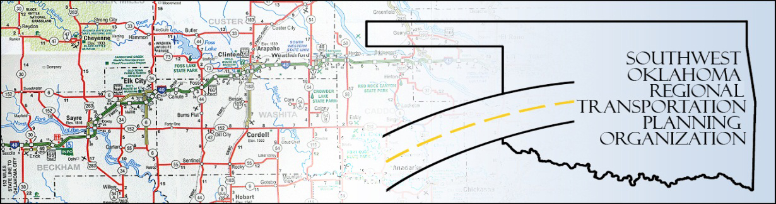

SORTPO

Policy Board Minutes
SWODA Conference Room
Building 420 Sooner Drive Burns Flat, OK 73624
Thursday, March 24, 2016
10:30 a.m.

Policy Board Members | P/A | Policy Board Members | P/A
Brent Almquist | A | Debora Glasgow | A
Anita Archer | P | Lyle Miller | P
Cary Carrell | P | Cendie Newman | P
Jeff Casida | P | Heather Sheppard | P
Jerry Dean | P | Mark Skiles | P
Marilyn Feaver | A | Clark Southard | A
Mike Galloway | A | Bill Spurlock | P

- Call to Order:

Chairman Lyle Miller welcomed members, and called the meeting to order.

- Roll Call:

Roll was called and it was declared a quorum was present. Also in attendance were SWODA staff members Alex Damon and Jana Harris.

3. Approval of Minutes: The minutes of the January 28, 2016 meeting was discussed. Motion was made to approve the minutes by Bill Spurlock and seconded by Cary Carrell, all in favor.

- Consider, discuss, and/or vote to adopt the updated Public Participation Plan (PPP). Changes to the PPP (following th public comment period) were discussed, and the plan was presented for approval/adoption.

- Board members received the proposed schedule of meetings for calendar year 2016. Discussion of the flexibility needed in the meeting schedule to allow for unforeseen deadlines and requirements from outside entities.

- Discuss progress in Roger Mills County and Beckham County LRTP: Alex Damon presented updates on the progress of the Long-Range Plans in Roger Mills and Beckham counties. Plans are on-schedule to date; more tables and projections are being amassed. The first Beckham County Stakeholder’s meeting is completed; another for the county is being planned to be help in Sayre.

7. Discuss updates and the applications to Transportation Alternatives Grant Program (TAP) through ODOT. Alex Damon presented information regarding the TAP application process; ODOT’s deadlines, as well as details about entities applying so far.
9. New Business: None at this time.

10. Remarks: Discussion of new school building construction in Elk City, and potential safety and traffic concerns.

11. Being no further business, motion to adjourn was made by Jerry Dean, seconded by Cary Carrell. Meeting was adjourned at 11:05.

ATTEST:

___________________________ _________________________
(Chairman) (Secretary)

