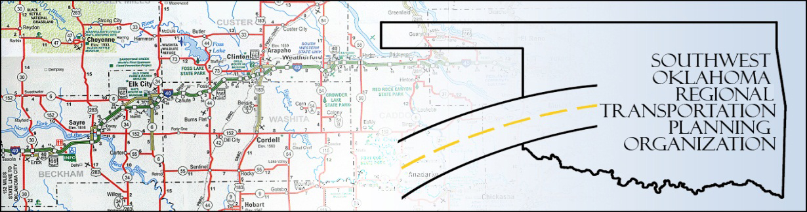

SORTPO

Technical Committee Minutes
SWODA Conference Room
Building 420 Sooner Drive
Burns Flat, OK 73624
Thursday, April 16, 2015
10:30 a.m.
Technical Committee Members | P/A | Technical Committee Members | P/A
Laura Chaney | P | Monty Profitt | P
Elesia Church | A | Joe Ridley | P
Alex Damon | P | Julie Sanders | A
Jana Harris | A | Basil Weatherly | P
Lee Littrell | P | Mike Weixel | A
Jim Mason | P

1. Call to Order:
The technical committee meeting was called to order by Alex Damon.

2. Roll Call – Introductions:

After roll call it was declared a quorum was present. Tim Tutten, Risk Manager with the Oklahoma Department of Transportation was introduced and will be a new member of the technical committee.

3. Approval of Minutes:

The minutes of the March 19th meeting were discussed. Motion was made by Basil Weatherly to approve minutes as is and seconded by Jim Mason, all in favor.
4. Discussion to Make Recommendations to the Policy Board in the following topics:

A. Endorsement of the SWODA/SORTPO Civil Rights Policies: The policies were discussed and recommended to take to the Policy Board for approval. Basil Weatherly made a motion to take the policies to the policy board and Joe Ridley seconded the motion, all in favor.
B. Review of 2016 Planning Work Program (PWP): Laura Chaney provided information, corrections and changes that needed to be done to follow the federal fiscal year. No action was needed. The Policy Board will adopt by September.
C. Acceptance of the draft 2035 Long Range Transportation Plan (LRTP): Alex explained that he was still working with different agencies to get data requested from Federal Highways to complete blanks in the LRTP. Discussion about prioritizing projects and making them more specific was discussed. There was also discussion about Exit 80 at Weatherford on Highway 54 and Exit 65 at Clinton being listed as projects. Basil Weatherly had a discussion about Southwestern Oklahoma State University campus with growth and north that bike lanes and sidewalks could be developed. There was discussion if the tribal offices had been contacted about participating. Lee Litterell made a motion recommending the Draft LRTP #10 preliminary to go to the Policy Board prior to final draft and Basil Weatherly seconded the motion, all in favor.
D. Set the 45-day Public Review and Comment Period for LRTP: Discussion was made about the period date for the Public Review. It was decided to recommend to the Policy Board the dates for review and comments would be May 1st for opening day and closing on June 15th. Motion was made by Basil Weatherly and seconded by Jim Mason, all in favor.
6. New Business:

The next Technical meeting will be May 21st. There was no other new business at this time.

7. Reports and Comments:

There were none at this time.

8. Adjourn:

Jim Mason made a motion to adjourn and Basil Weatherly seconded the motion, all in favor. Meeting was adjourned at 11:22 a.m.

