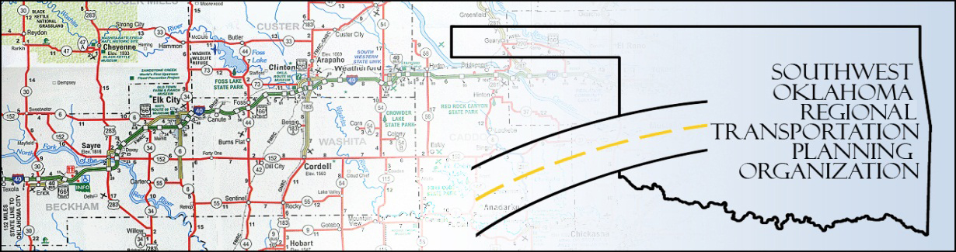

SORTPO Policy Board

Meeting Agenda
SWODA Conference Room
Building 420 Sooner Drive
Burns Flat, OK 73624
August 25, 2016, 10:30 a.m.
- Call to Order
- Roll Call – declaration of a quorum
- Approval of Minutes for the June 23, 2016 meeting.
- Discuss and provide comments on the 2036 Beckham County LRTP.
- Discuss and approve a 30-day public review and comment for the 2036 Beckham County LRTP.
- Discuss and provide comments on the 2036 Roger Mills County LRTP.
- Discuss and approve a 30-day public review and comment period for the 2036 Roger Mills County LRTP.
- Discuss and provide comments amending the 2035 Custer County LRTP.

- Discuss and consider approving a 30-day public review and comment period for the amendment of the 2035 Custer County LRTP.

- New Business.
- Reports and Comments.
- Adjourn.

