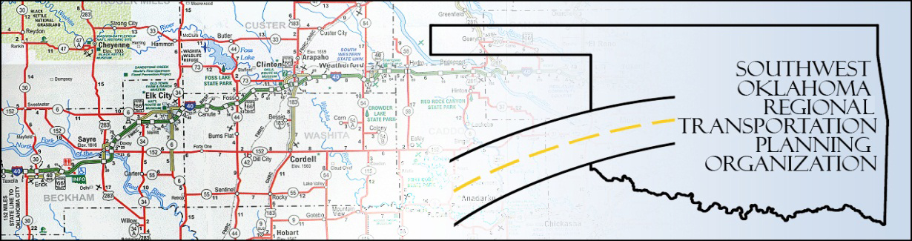

SORTPO Technical Committee

Special Meeting

Agenda
SWODA Conference Room
Building 420 Sooner Drive Burns Flat, OK 73624
August 24, 2016 10:00 a.m.
- Call to Order

- Roll Call – Introductions

- Approval of the minutes for the May 19, 2016 meeting.

- Discuss the revised 2035 Population and Employment Projections for Beckham County and Roger Mills County LRTPs approved by the SORTPO Policy Board.

- Discuss provide comments and recommend the SORTPO Policy Board established a 30-day public review and comment period prior to adoption of the 2035 Beckham County LRTP.

- Discuss provide comments and recommend the SORTPO Policy Board established a 30-day public review and comment period prior to adoption of the 2035 Roger Mills County LRTP.

- Discuss provide comments and recommend the SORTPO Policy Board established a 30-day public review and comment period prior to adoption of an amendment to the 2035 Custer County LRTP.

- New Business

- Reports and Comments

- Adjourn

