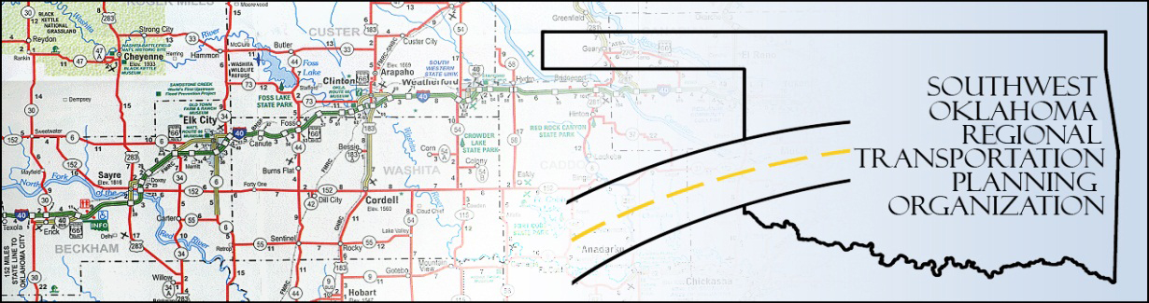

SORTPO Public Hearing

Meeting Agenda
SWODA Conference Room
Building 420 Sooner Drive
Burns Flat, OK 73624
September 29, 2016, 10:00 a.m.
- The purpose of the public hearing is to discuss the Long Range Transportation Plans for Beckham and Roger Mills Counties.

