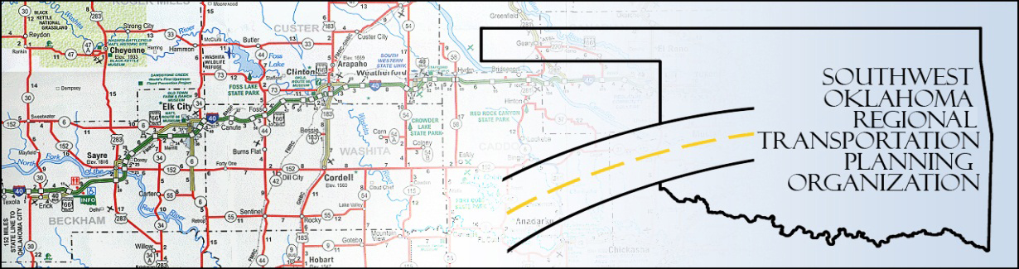

SORTPO

Policy Board Minutes
SWODA Conference Room
Building 420 Sooner Drive Burns Flat, OK 73624
Thursday, September 29, 2016
10:05 a.m.

POLICY BOARD MEMBERS | P/A | POLICY BOARD MEMBERS | P/A
Brent Almquist | A | Debora Glasgow | P
Anita Archer | P | Lyle Miller | P
Kirk Butler | A | Cendie Newman | A
Jeff Casida | P | Heather Sheppard | A
Jerry Dean | P | Mark Skiles | P
Marilyn Feaver | A | Clark Southard | P
Mike Galloway | P | Bill Spurlock | A

1. Call to Order:
Meeting called to order at 10:05 a.m. by Chairman Lyle Miller.

2. Roll Call and declaration of quorum:
By Becky Cockrell–quorum declared.

3. Approval of Minutes: The minutes of the August 25, 2016 were approved with no change. Motion was made by Clark Southard to approve the minutes and seconded by Mark Skiles, motion passed.

4. Discuss and approve the 2036 Beckham County LRTP. Motion was made by Clark Southard to approve the 2036 Beckham County LRTP and seconded by Jerry Dean, motion passed.
5. Discuss and approve the 2036 Roger Mills County LRTP. Motion was made by Jerry Dean to approve the 2036 Roger Mills LRTP and seconded by Anita Archer, motion passed.
6. Discuss and approve the amendment to the 2035 Custer County LRTP. Motion was made by Jerry Dean to approve the amendment to the 2035 Custer County LRTP and seconded by Mike Galloway, motion passed.
7. Discuss and voted to approve the updated Planning Work Program (PWP). Motion was made by Clark Southard to approve the 2017 Planning Work Program (PWP) and seconded by Mark Skiles, motion passed.

8. Approve Resolution for the 2036 Roger Mills County LRTP. Motion was made by Anita Archer to assign the 2036 Roger Mills LRTP with a Resolution number and was seconded by Mike Galloway, motion passed.
9. Approve Resolution for the 2036 Beckham County LRTP. Motion was made by Mark Skiles to assign the 2036 Beckham County LRTP with a Resolution number and was seconded by Clark Southard, motion passed.
10. New Business: Jana Harris reminded the Policy Board and visitors about the Road Diet workshop that ODOT will be putting on October 20, 2016 that you must register to attend. Jana Harris also discuss with the Policy Board and Technical Committee about the changes that will be coming up for the following 2017 Transportation Planning. SORTPO and ASCOG will be working together to help with ASCOG’S 8 counties Regional Plans.
11. Reports and Comments:
12. Adjourn: Being no further business, motion made by Clark Southard and seconded by Anita Archer, motion passed to adjourn the meeting. Meeting was adjourned at 11:45 a.m.

ATTEST:

___________________________ _________________________
(Chairman) (Secretary)

