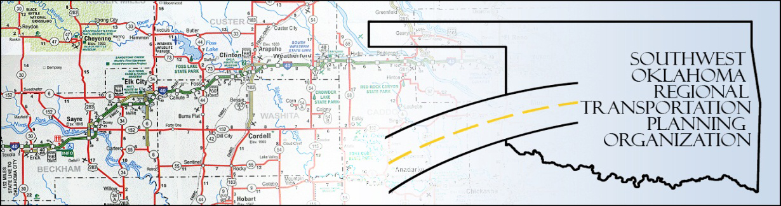

SORTPO

Public Hearing
SWODA Conference Room
Building 420 Sooner Drive Burns Flat, OK 73624
Thursday, September 29, 2016
10:00 a.m.

Call to order: Meeting was called to order at 10:00 a.m. by Lyle Miller.

There was no additional public in attendance for remarks.
Adjourn: Being no remarks from the public, motion made by Clark Southard and seconded by
Anita Archer, motion passed to adjourn the meeting. Meeting was adjourn at 10:03 a.m.

