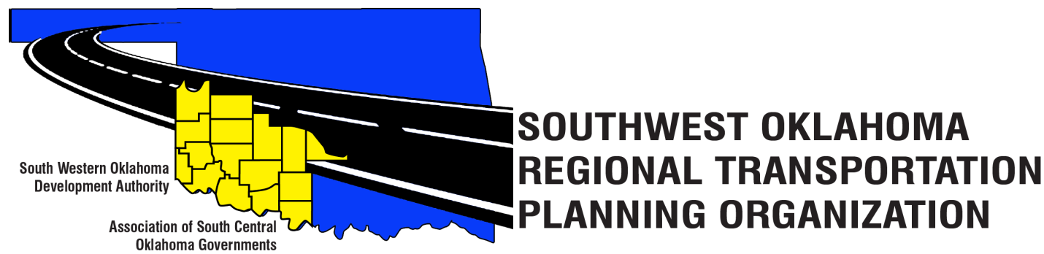
SORTPO Policy Board

Meeting Agenda

Western Technology Center
Adult Education Bldg 621 Sooner Dr.
Burns Flat, OK 73624
&
Red River Technology Center
JDM Business Center, Rm B113
3300 W. Bois D’Arc
Duncan, OK 73533

January 26, 2017 10:30 a.m.

- Call to Order
- Roll Call – Introductions
- Approval of the minutes for the December 8, 2016 meeting.
- Discuss County stakeholders meeting schedule
 | Stakeholder Meeting Date & Time | Meeting Location
Cotton | 2/15; 1:30p | Cotton Electric Civic Room (to be confirmed)
Greer | 2/9; 9:00a | Mangum Chamber of Commerce  119 E. Jefferson St.
Harmon | 2/9; 1:00p | Hollis City Hall  208 W. Jones St.
Jackson | To be scheduled | To be determined
Jefferson | 2/21; 9:30a | Waurika to be determined
Stephens | 2/21; 1:30p | Red River Technology Center JDM Business Center 3300 W. Bois D’Arc  Duncan, OK
Tillman | 2/15; 9:00a | Great Plains Technology Center Tillman/Kiowa Campus 2001 E. Gladstone Ave.  Frederick, OK

- Discuss and provide direction to staff in collection of data, identification of key issues-concerns, trends and the role of public participation in the Transportation Planning Process.

- New Business

- Reports and Comments
  - Technical Committee Meeting 1-19-17
  - Discuss meeting date in February 2017

- Adjourn

