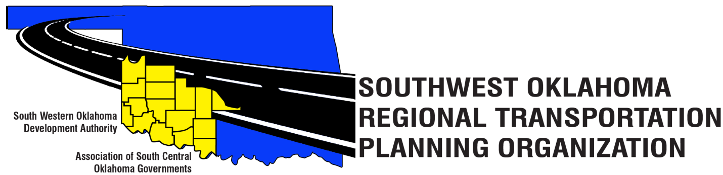

SORTPO

Policy Board Minutes
SWODA Conference Room
Building 420 Sooner Drive Burns Flat, OK 73624
Thursday, December 08, 2016
10:30 a.m.

POLICY BOARD MEMBERS | P/A | POLICY BOARD MEMBERS | P/A
Brent Almquist | P | Debora Glasgow | P
Anita Archer | P | Lyle Miller | P
Kirk Butler | P | Cendie Newman | A
Jeff Casida | P | Heather Sheppard | P
Jerry Dean | A | Mark Skiles | A
Marilyn Feaver | A | Clark Southard | A
Mike Galloway | P | Bill Spurlock | P

1. Call to Order:
Meeting called to order at 10:30 a.m. by Chairman Lyle Miller.

2. Roll Call and declaration of quorum:
By Becky Cockrell–quorum declared.

3. Approval of Minutes:

The minutes of the September 29, 2016 were approved with no change. Motion was made by Jeff Casida to approve the minutes and seconded by Debora Glasgow, motion passed.

4. Discuss and approve the amendment to the FFY 2017-18 PWP:
Motion was made by Jeff Casida to approve the amendment to FFY 2017-18 PWP and seconded by Anita Archer , motion passed.
5. Discuss and approve the amendment to the updated By-Laws for the FFY 2017-18 PWP:
Motion was made by Anita Archer to approve the amendment to the updated By-Laws and seconded by Kirk Butler, motion passed.

6. Discuss and approve setting a 45-day public review period for the Public Participation PPP:
Motion was made by Kirk Butler to setting a 45-day public review period for the Public Participation PPP and seconded by Jeff Casida, motion passed.
7. Discuss and approve the 2017 meeting schedule:

Motion was made by Anita Archer to approve the 2017 meeting schedule and seconded by Jeff Casida, motion passed.

8. New Business:
Jana Harris reminded the Policy Board and visitors that starting in January 2017 we will be have our first teleconferences. The meeting places will be held at the Western Tech. Center in Burns Flat, Oklahoma and Red River Tech. Center in Duncan, Oklahoma. Jana Harris also reminded the Policy Board the changes that will be coming up for the following 2017 Transportation Planning. SWODA and ASCOG will be working together to make SORTPO a 16 counties Regional Plans.
9. Reports and Comments:
Mike Galloway suggested that we come up with a plan for Road Closes. Brent Almquist recommended that ODOT uses Radio, Newspaper, Schools and Business to share where they are having road closes.
10. Adjourn:
Being no further business, motion made by Mike Galloway and seconded by Anita Archer, motion passed to adjourn the meeting. Meeting was adjourned at 11:45 a.m.

ATTEST:

___________________________ _________________________
(Chairman) (Secretary)

