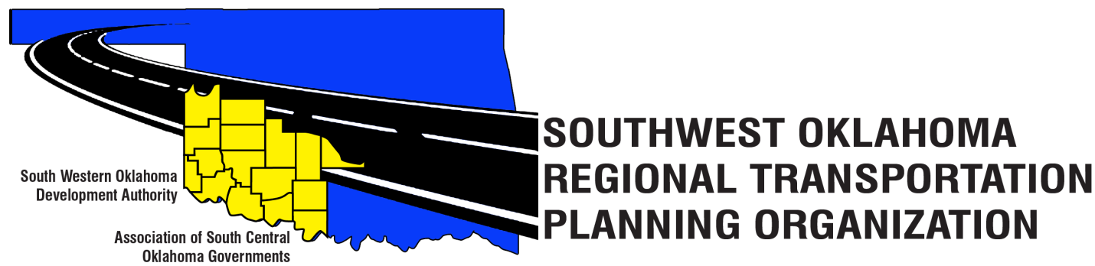
SORTPO Policy Board

Meeting Agenda
March 23, 2017 10:30 a.m.
Western Technology Center  Adult Education Bldg,  621 Sooner Dr.  Burns Flat, OK 73624 | Red River Technology Center  JDM Business Center, Rm B113  3300 W. Bois D’Arc  Duncan, OK 73533
- Call to Order

- Roll Call – Introductions

- Approval of the minutes for the February 23, 2017 meeting.

- Discuss and approve the Public Participation Plan (PPP) to include the 16 county SORTPO region.

- Discuss and consider approving 2040 population and employment projections for Cotton, Greer, Harmon, Jackson, Jefferson, Stephens and Tillman Counties. (Attachments 1A-1G)

- Old Business

- Reports and Comments

- Adjourn

