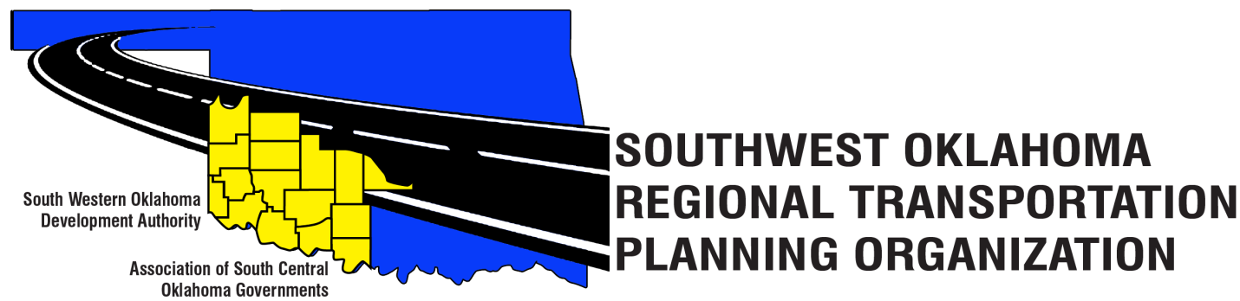

SORTPO

Technical Committee Minutes
April 13, 2017
10:00 a.m.

Western Technology Center | Red River Technology Center
Adult Education Bldg 621 Sooner Dr. | JDM Business Center, Rm B113
Burns Flat, OK 73624 | Duncan, OK 73533

Technical Committee Members | P/A | Technical Committee Members | P/A
Bryce Bohot | P | Monty Profitt | A
Elesia Church | P | Basil Weatherly | P
Jana Harris By Phone | P | Mike Weixel | A
Lee Litterell | A | Steve Kelly | P
Jim Mason | A | John Sheppard By Phone | P
Jeff Morton | P | Kevin Ouellette By Phone | P
Others in attendance included: Becky Cockrell, SORTPO; Julie Sanders Consultant;

1. Call to Order:

The Technical Committee meeting was called to order by Becky Cockrell.
2. Roll Call – Introductions:

Becky Cockrell- quorum declared

3. Approval of Minutes:

The minutes of the March 9, 2017 meeting were reviewed. Motion was made by Elesia Church to approve minutes and seconded by Jeff Morton, motion passed.

4. Discuss and consider recommending to the SORTPO Policy Board the following:

A.) Discuss Goal categories and strategies for Cotton, Greer, Harmon, Jackson, Jefferson, Stephens, & Tillman County 2040 LRTP. Comments from the Technical Committee members were incorporated into the recommended revisions. The Committee recommended adding Tourism Goal to Jefferson, Stephens, and Tillman Counties. Discussion on including a specific goal for Altus Air Force Base was also discussed. This goal could also be a strategy under an existing goal. (Attachment 1a-1g additions are shown with an underline and deletions are shown by strikethrough. Comments from the Technical Committee members were incorporated into the recommended revisions. Motion was made by Steve Kelly to recommend that the Policy Board consider the (attachment 1a-1g), seconded by Bryce Bohot, motion passed.

B.) Key issues, trends, and challenges for Cotton, Greer, Harmon, Jackson, Jefferson, Stephens, & Tillman County 2040 LRTP. Comments discussed that several key issues, trends, and concerns should be included in each LRTP. Information from survey results were shared. (Attachment 2a-2g additions are shown with an underline and deletions are shown by strikethrough. Motion was made by Elesia Church to recommend that the Policy Board consider the (attachment 2a-2g), seconded by Jeff Morton, motion passed.

7. Old Business:

8. Reports and Comments: Elesia Church reported that she had attended the “Strong Towns Summit” in Tulsa Oklahoma. She encouraged everyone that if the opportunity arises that you should attend a session. The link for more information. http://www.strongtowns.org/

9. Adjourn:

Basil Weatherly moved adjournment, Elesia Church seconded.

