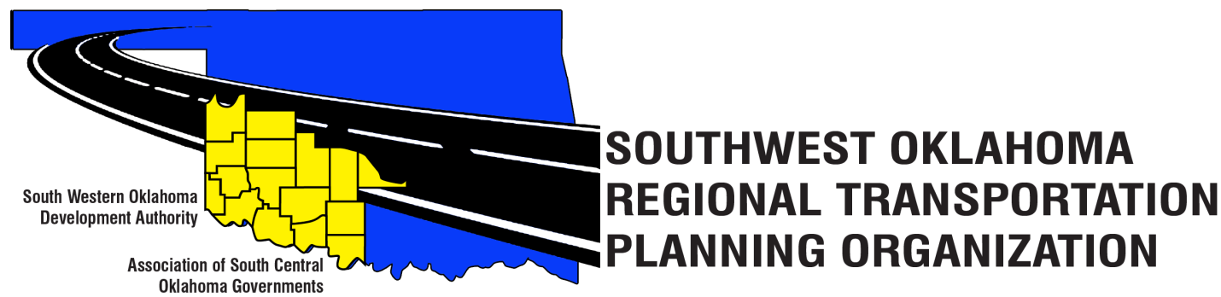
SORTPO Policy Board
Meeting Agenda
May 25, 2017 10:30 a.m.
Western Technology Center  Adult Education Bldg,  621 Sooner Dr.  Burns Flat, OK 73624 | Red River Technology Center  JDM Business Center, Rm B113  3300 W. Bois D’Arc  Duncan, OK 73533
- Call to Order
- Roll Call – Introductions
- Approval of the minutes for the April 27, 2017 meeting.
- Discuss comments provided by the SORPTO Transportation Technical Committee on the 2040 LRTP for Greer, Harmon, Jackson, Jefferson and Stephens Counties and provide direction to staff.

- Old Business

- Reports and Comments

- Adjourn

