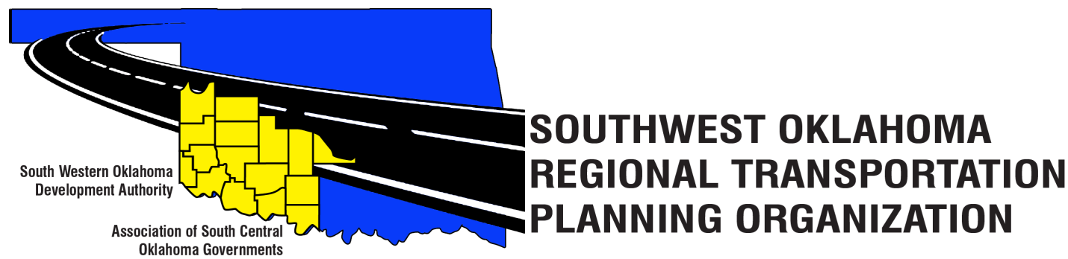
SORTPO Policy Board
Meeting Agenda
August 24, 2017 10:30 a.m.
Western Technology Center  Adult Education Bldg,  621 Sooner Dr.  Burns Flat, OK 73624 | Red River Technology Center  JDM Business Center, Rm B113  3300 W. Bois D’Arc  Duncan, OK 73533
- Call to Order
- Roll Call – Introductions
- Approval of the minutes for the June 22, 2017 meeting.
- Discuss and provide comments on the following draft:
  - 2040 Greer County Long Range Transportation Plan
  - 2040 Harmon County Long Range Transportation Plan
  - 2040 Jackson County Long Range Transportation Plan
  - 2040 Jefferson County Long Range Transportation Plan
  - 2040 Stephens County Long Range Transportation Plan

- Discuss and consider establishing a 30-day public review and comment period (August 28, 2017 – September 26, 2017) to solicit comments on the 2040 Long Range Transportation Plans for the Counties of Greer, Harmon, Jackson, Jefferson, and Stephens).

- Discuss and provide comments on the draft FFY 2017-2018 (October 1, 2017 – September 30, 2017) Planning Work Program.

- Discuss and consider approving the Transportation Planning Consultant Request for Proposal.

- Discuss and consider approval:
A. Memorandum of Understanding between SWODA/ASCOG (SORTPO) and ODOT.
B. State Planning & Research (SPR) Funding Agreement between SORTPO and ODOT.

- New Business

- Reports and Comments

- Adjourn.

