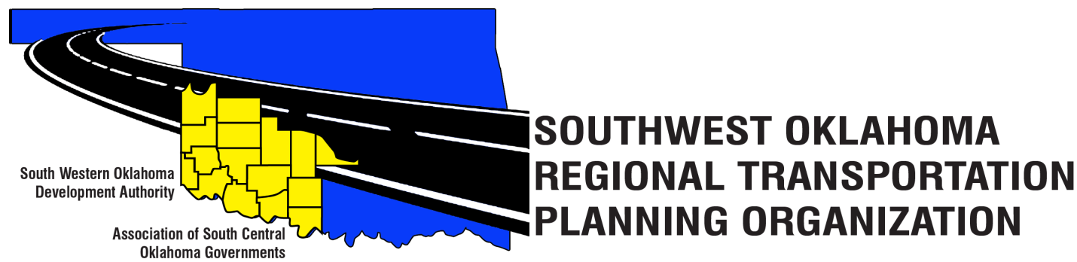
SORTPO Technical Committee

Meeting Agenda
August 17, 2017 10:00 a.m.
Western Technology Center  Adult Education Bldg,  621 Sooner Dr.  Burns Flat, OK 73624 | Red River Technology Center  JDM Business Center, Rm B113  3300 W. Bois D’Arc  Duncan, OK 73533
- Call to Order
- Roll Call – Introductions
- Approval of the minutes for the June 15, 2017 meeting.
- Discuss and provide comments to the Transportation Policy Board on the following:
  - 2040 Greer County Long Range Transportation Plan
  - 2040 Harmon County Long Range Transportation Plan
  - 2040 Jackson County Long Range Transportation Plan
  - 2040 Jefferson County Long Range Transportation Plan
  - 2040 Stephens County Long Range Transportation Plan
- Discuss and recommend to the SORTPO Policy Board establishing a 30-day public review and comment period (August 28, 2017 – September 26, 2017) to solicit comments on the 2040 Long Range Transportation Plans for the Counties of Greer, Harmon, Jackson, Jefferson, and Stephens).
- Discuss and provide comments on the draft FFY 2017-2018 Planning Work Program to the SORTPO Policy Board
- Discuss and provide recommendation to the SORTPO Policy Board on the Transportation Planning Consultant Request for Proposal.

- New Business.

- Reports and Comments.

- Adjourn.

